Course Name: | Web Development Laboratory | Semester: | V
Date of Performance: | 18/08/26 | DIV/ Batch No: | A1
Student Name: | Aditya Chaugala | Roll No: | 16014024012

Experiment No: 4
Title To design and develop a responsive, component-rich Web Portal using the Bootstrap
framework, incorporating grids, layouts, navigation, alerts, input groups, pagination, and custom styled components.

Aim and Objective of the Experiment:
- To develop JavaScript applications using arrays, operators, functions, events, DOM manipulation, and form validation to solve practical problems.
- To implement asynchronous programming using callbacks, nested callbacks, Promises, Promise chaining, and async/await for sequential application-based operations.
- To handle user interactions and errors effectively using event handling, input validation, try-catch, and appropriate asynchronous error-handling techniques.

COs to be achieved:
CO2:

Problem Statement:
Task1: Create an array of product prices. Calculate the total bill, apply a discount if the total exceeds a specified amount, and display the final amount.

Task 2: Create buttons such as Submit, Cancel, and Reset. When a button is clicked, change its own text using the this keyword.

Task 3: Create a text box where the number of characters entered is displayed dynamically whenever the user types.

Task 4: Create a registration form with name, mobile number, email, password, confirm password, and gender. Validate all fields before submission.

Task 5: Simulate the following sequence using nested callbacks:
Select Food → Confirm Order → Prepare Food → Assign Delivery Partner → Deliver Food.
Display an appropriate message after each operation.

Task 6: Create a program that simulates:
Select Product → Check Availability → Add to Cart → Make Payment → Generate Order Confirmation.
Each operation should return a Promise and be executed using promise chaining.

Task 7: Develop a program to simulate:
Select Movie → Check Seat Availability → Reserve Seat → Make Payment → Generate Ticket.
Use async/await and try...catch for error handling.

HTML tags used:
- <!DOCTYPE html>
- <html>
- <head>
- <meta>
- <title>
- <link>
- <body>
- <div>
- <header>
- <h1>
- <nav>
- <button>
- <main>
- <section>
- <h2>
- <p>
- <textarea>
- <span>
- <form>
- <label>
- <input>
- <select>
- <option>
- <script>

Code:
Link for the repo: https://github.com/AdiCynth/Web_program_lab.git

Stepwise-Procedure / Algorithm:
Step 1: Create a project folder and set up index.html, styles.css, and app.js.

Step 2: In index.html, define the basic document structure using <!DOCTYPE html>, <html>, <head>, and <body> tags.

Step 3: Inside <head>, add <meta> tags, a <title>, and a <link> to attach styles.css.

Step 4: Add a <header> section with an <h1> for the lab title.

Step 5: Create a <nav> bar with <button> tags for tabs, using class="active" for the current task.

Step 6: Inside <main>, add task-specific content using <section> containers, <h2> headings, <form> elements, and <button> triggers.

Step 7: In styles.css, write rules targeting the above tags to apply a clean layout and hide inactive tabs.

Step 8: In app.js, attach event listeners to manipulate the DOM (tab switching, array reduction, form validation, and async flows).

Step 9: Open index.html in a browser and verify that the UI loads and all JavaScript tasks execute correctly.

Output
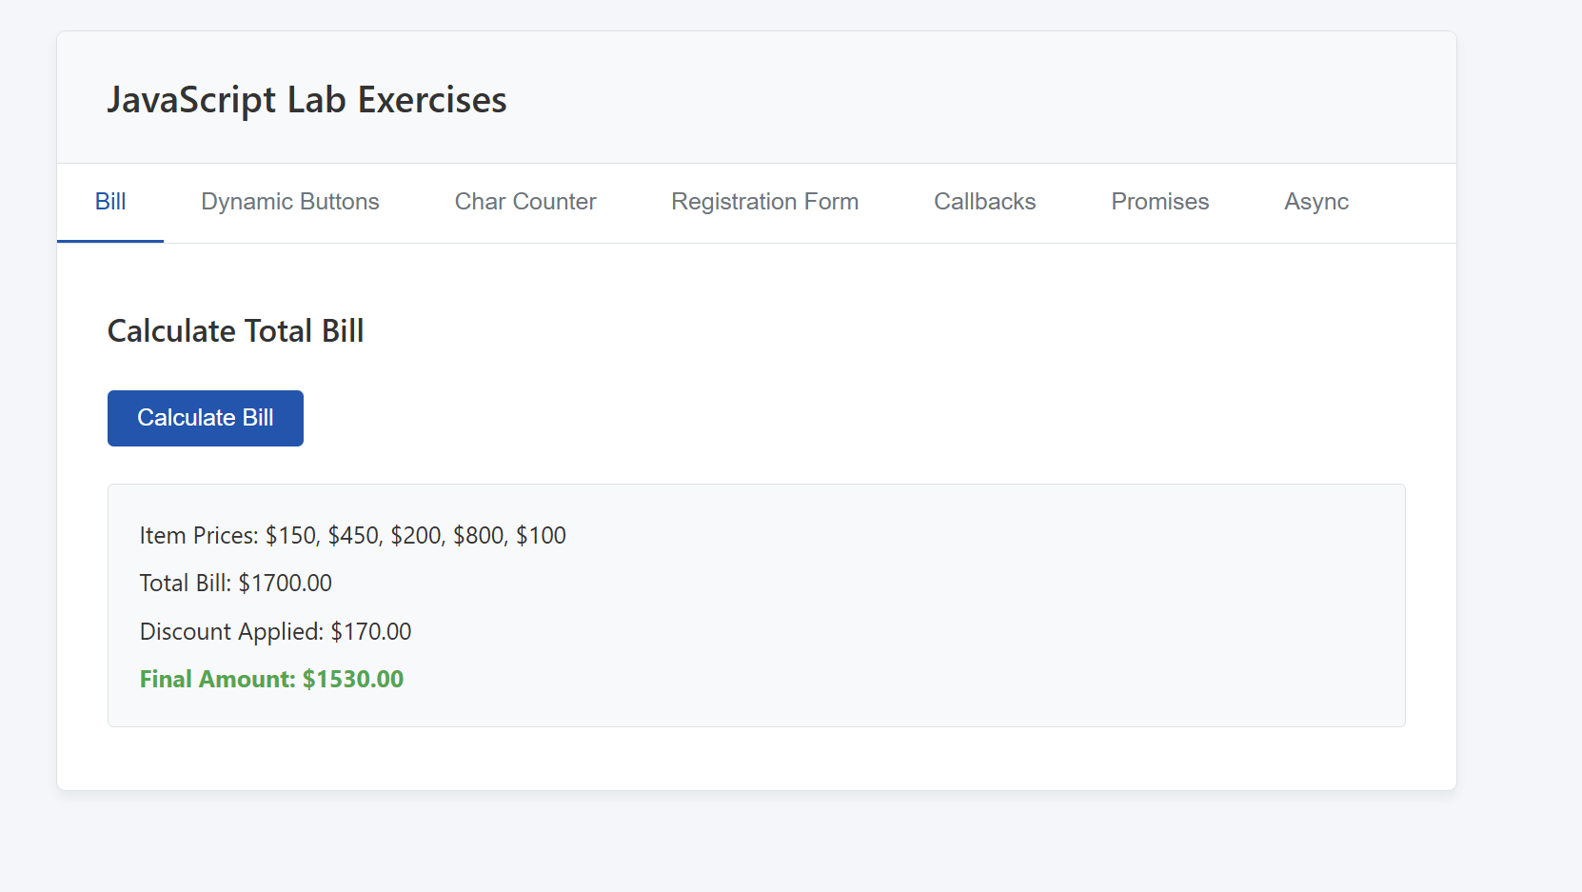

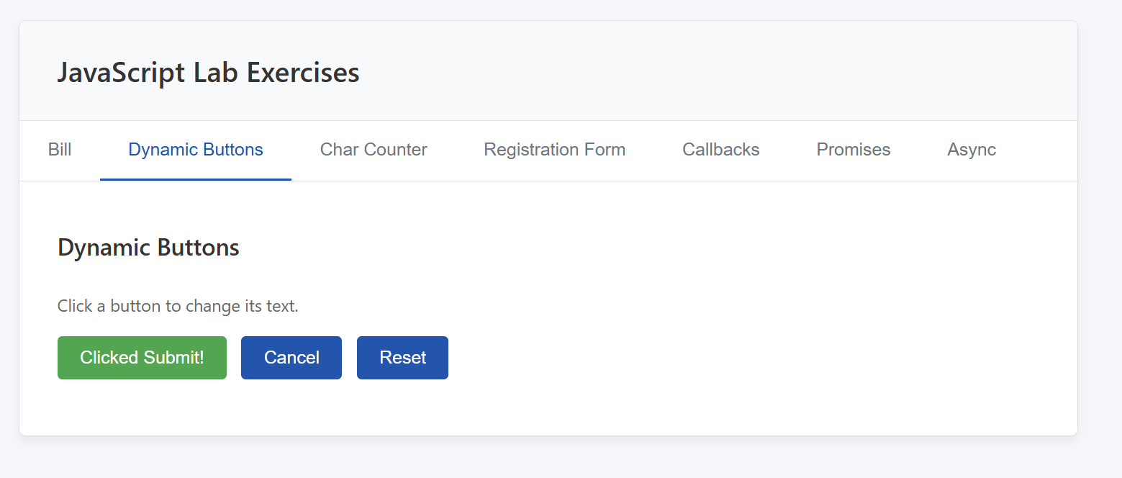

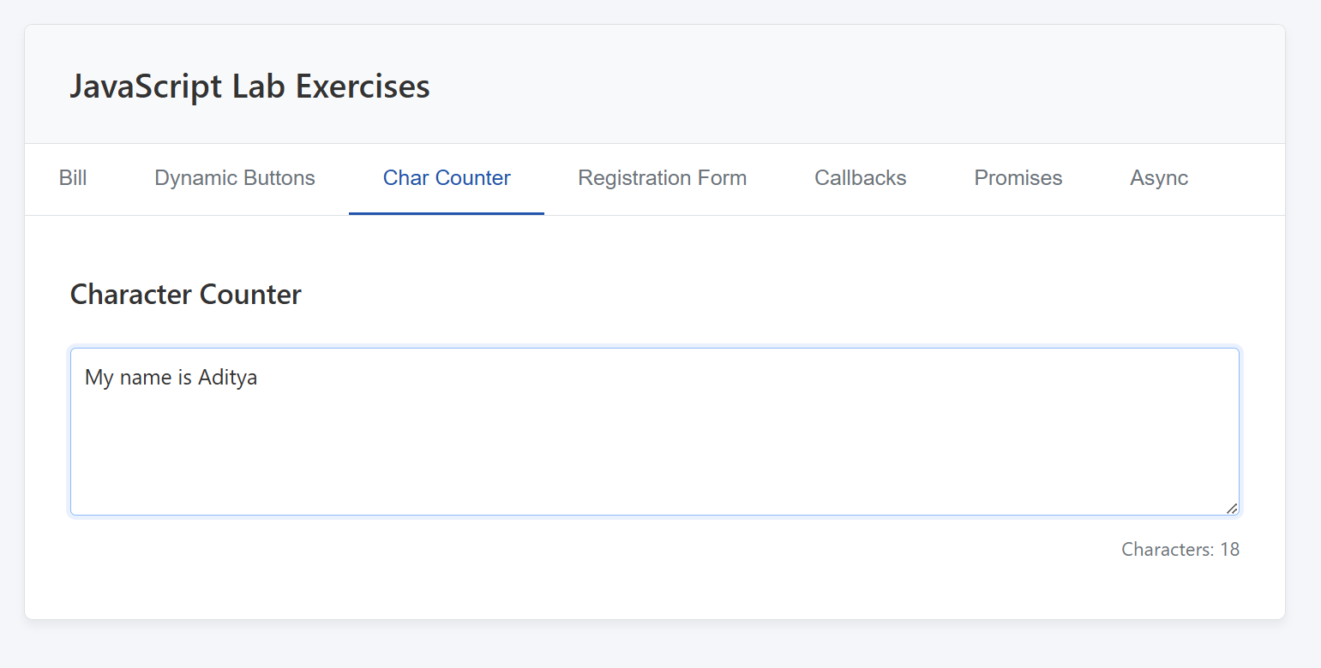

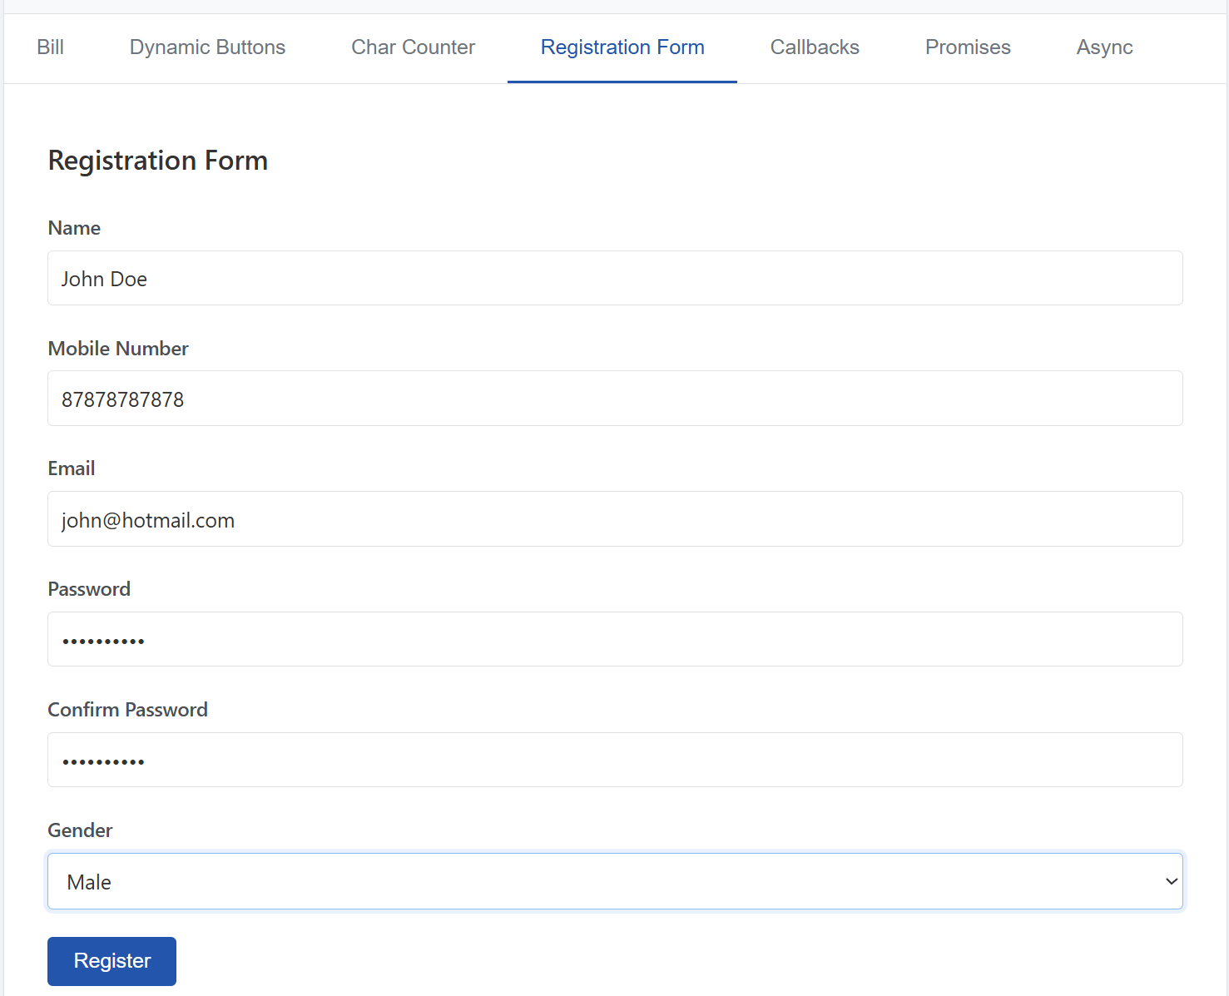

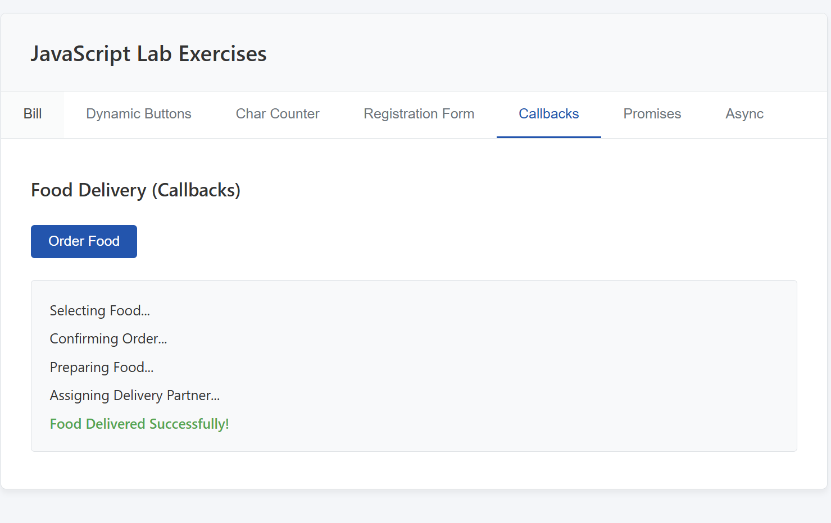

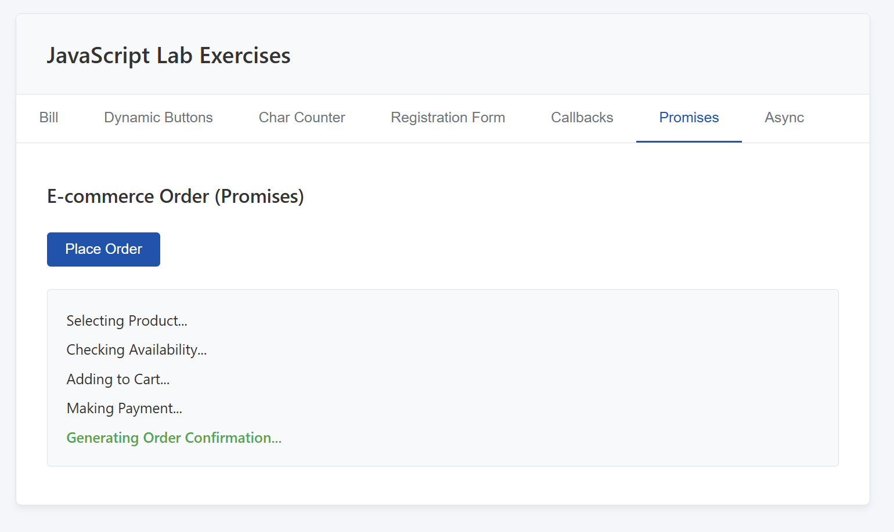

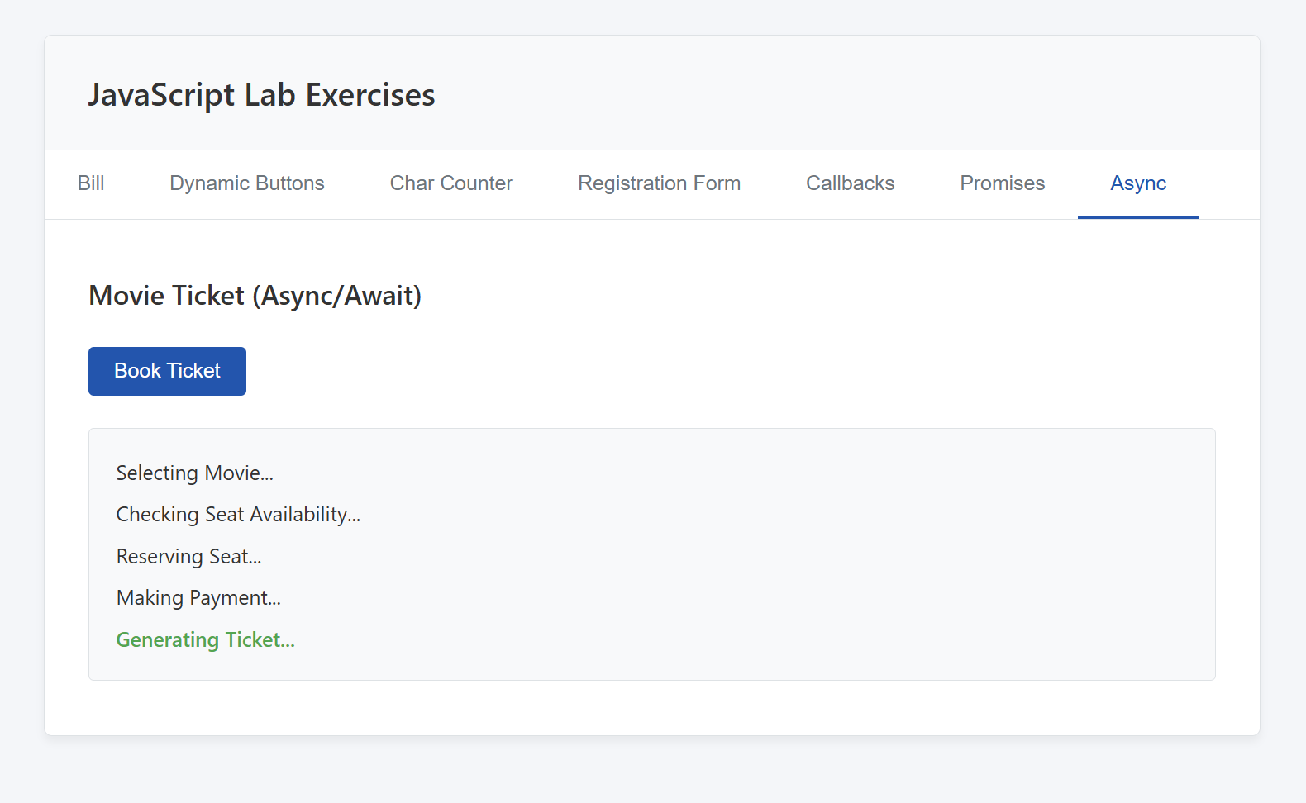

Link of the Generated website

Post Lab Subjective/Objective type Questions:
- What is the use of containers in bootstrap? Explain in detail.
- Name the classes to achieve the different button styles in bootstrap.
- Write details about the Bootstrap Grid system.

Conclusion:
This experiment successfully demonstrated fundamental to intermediate JavaScript concepts. By building an interactive web application, we practically implemented DOM manipulation, event handling, array methods, and form validation. Furthermore, exploring nested callbacks, promises, and async/await provided crucial insights into managing asynchronous operations for modern web development.

Signature of faculty in-charge with Date:

